**Go Spain**

Go Spain is a site which helps people who are planning their travel to Spain. The main goal is to organize and standardize the journey towards perfectionism and to give a great information about the beautiful places in Spain, so that people can plan and enjoy the trip of their dreams.

## **Features**

Go Spain site is developed with the following features:

**Existing Features**

* **Navigation Bar**
* Features on all three pages, the full responsive navigation bar includes links to the Logo, Home page, Destinations and Contact.
* This section will allow the user to easily navigate from page to page across all devices, without having to revert to the previous page.



* **The landing page image**
* **The landing page includes a photograph of four cities in Spain with text overlay to allow the user to see exactly which location in Spain would be applicable to.**
* **This includes links to the relevant places in Spain that you would like to visit/know. The links will open to a new tab to allow easy navigation to the user.**
* **This section introduces the user to Go Spain with an eye-catching animation to grab users’ attention.**

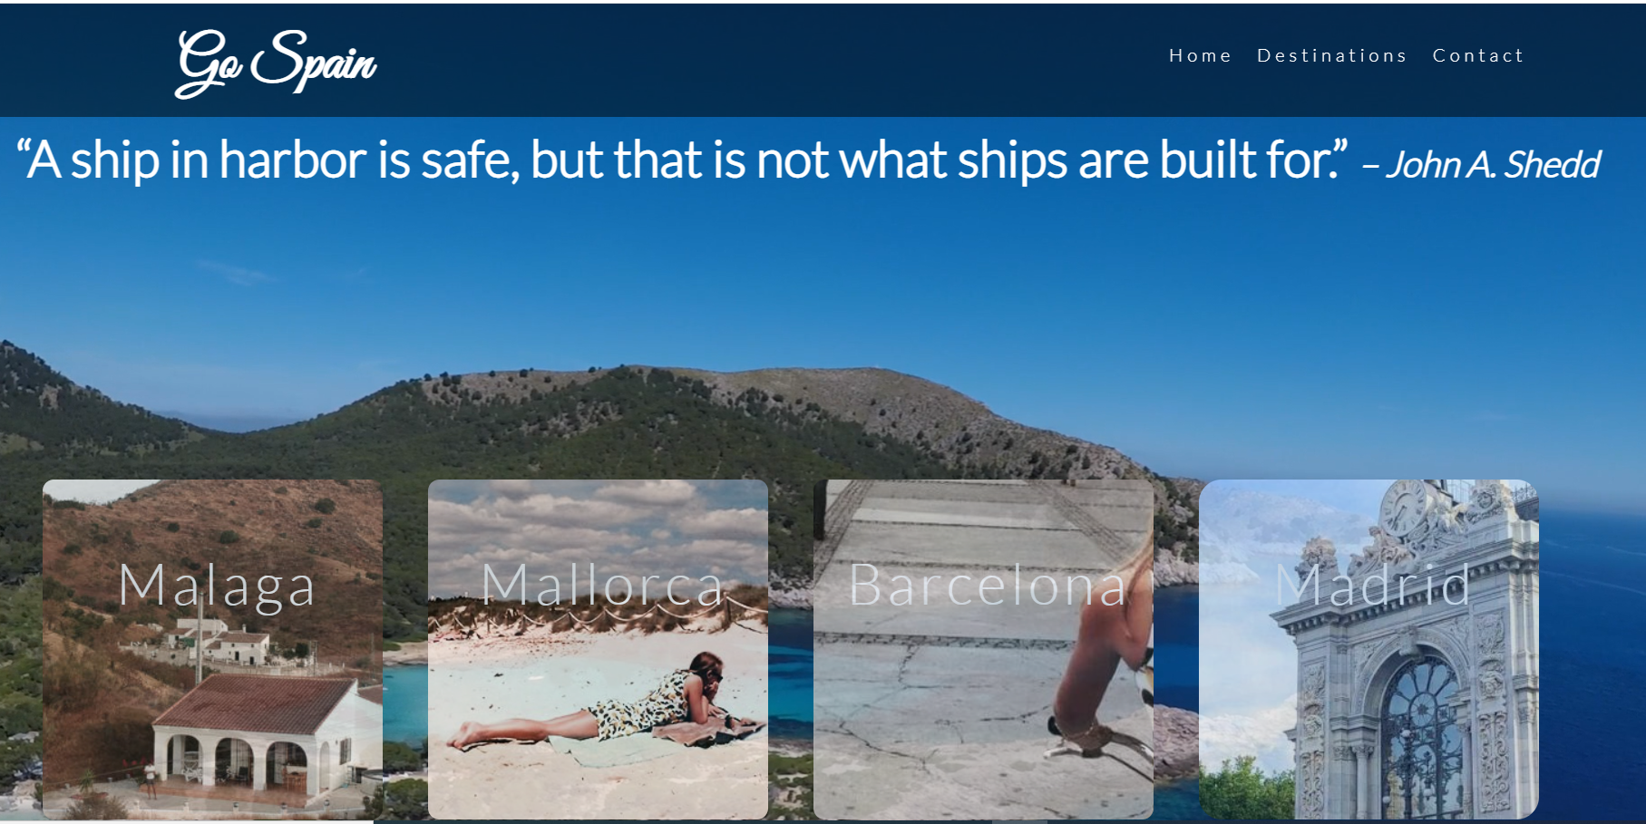

* **Travelers statistics around the world**
* This section will allow the user to see the total number of travelers to Spain, from which countries most of the people are traveling to Spain, what are the main destinations of travelers and percentage of people traveling to Spain since year 2020.
* This should encourage the user to consider Spain for a holiday.



* **Secrets of Spain**
* This section will allow the user to know why you consider visiting Spain for a trip and this includes the interesting facts of Spain, tips to avoid traps and whereabouts of author to the ‘Go Spain’.
* This section will be updated as these times change to keep the user up to date.

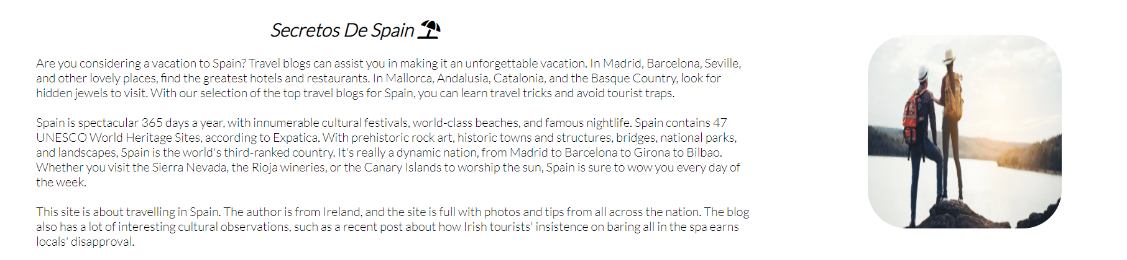

* **Map**
* This section will allow the user to check the places in the map. User can tap on the view larger map to see larger view and can adjust the zoom by clicking ‘+’ and ‘- ‘.

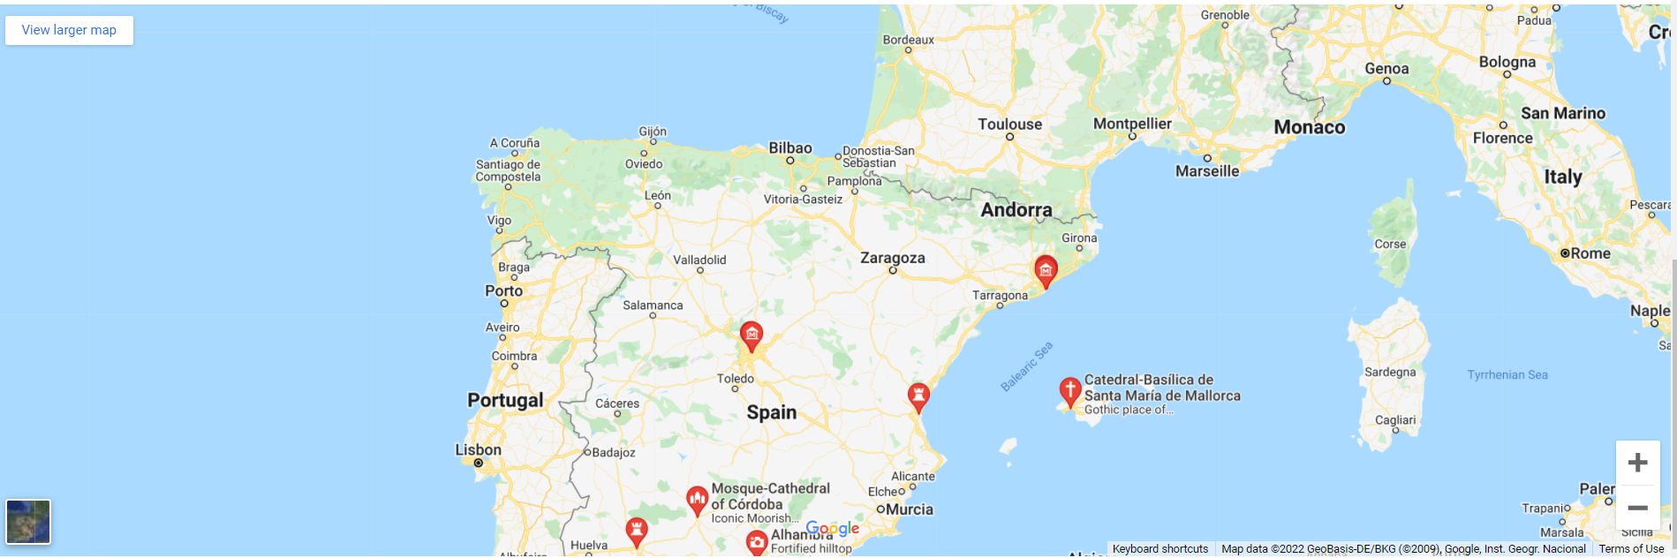

* **The Footer**
* The footer section includes links to the relevant social media sites for Go Spain. The links will open to a new tab to allow easy navigation for the user.
* The footer is valuable to the user as it encourages them to keep connected via social media.



* **Destinations**

This section includes some more detailed information of the trip including plan, meals, and some must visit places.

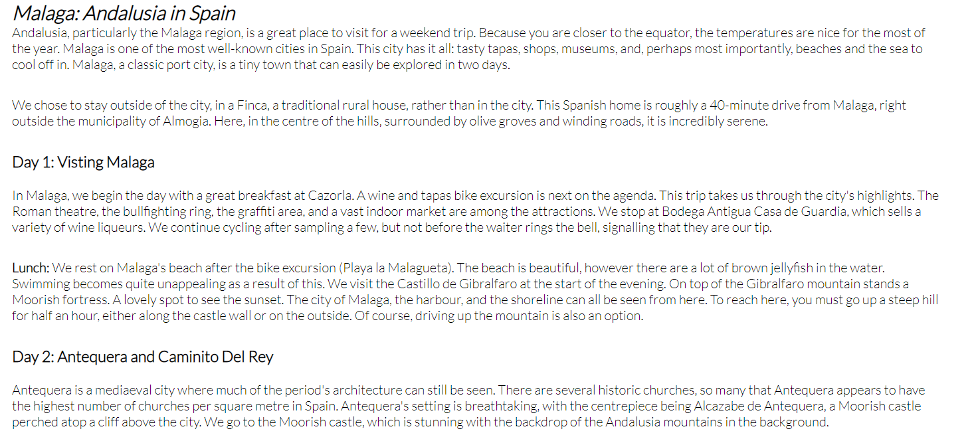

* **Contact us**
* This page will allow the user to contact if they have any other relevant questions about Go Spain. The user will be asked to submit their full name, email, and message.

